AGLA II Coding Exercise

Gleb Popov, B23-ISE-01

*Innopolis University*

**Points**

A dataset contains 20 points with integer coordinates.

|  |  |  |  |  |  |  |  |  |  |  |
| --- | --- | --- | --- | --- | --- | --- | --- | --- | --- | --- |
| **x** | 10 | 4 | 15 | 20 | 25 | 41 | 43 | 30 | 22 | 28 |
| **y** | 5 | 15 | 5 | 12 | 20 | 28 | 30 | 35 | 19 | 30 |

|  |  |  |  |  |  |  |  |  |  |  |
| --- | --- | --- | --- | --- | --- | --- | --- | --- | --- | --- |
| **x** | 7 | 35 | 34 | 20 | 25 | 46 | 44 | 17 | 2 | 42 |
| **y** | 12 | 40 | 35 | 22 | 20 | 20 | 15 | 10 | 20 | 20 |

**Least Square Approximation**

Function’s approximation with degree 3.

$$f\left(x\right)≈-0.0040x^{3}+0.2796x^{2}-4.7067x+29.3661$$

**Graph**

Points from dataset and approximation line.

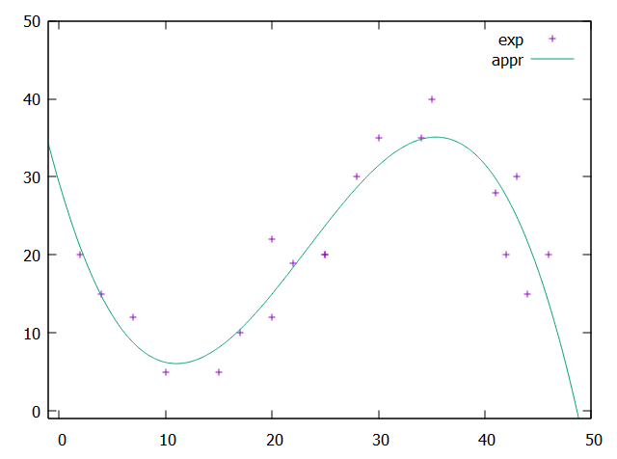

**Code**

Available via the link <https://glebpopov.notion.site/AGLA-2-Graph-Gleb-Popov-042c5013241644ac9d53b112e4a805a4?pvs=4>